|  |  |  |
| --- | --- | --- |
| DSDEN Val d'Oise |  | Année scolaire 2025-2026 |
|  |  |
| **A remettre au collège de** |  | **Demande d'affectation** |
| **secteur** |  | **COLLEGE DE SECTEUR** |
|  |  |



**Les dossiers sont à déposer auprès du chef d'établissement de votre collège de secteur, la décision d'affectation est de la compétence de M. le Directeur académique des services départementaux de l'Education nationale, elle est matérialisée par un avis d'affectation.**



**ELEVE**

|  |  |  |  |  |  |  |
| --- | --- | --- | --- | --- | --- | --- |
| NOM : |  | Prénom : |  | Date de naissance : |  |  |
|  |  |  |  |  |  |  |



**REPRESENTANTS LEGAUX - Coordonnées des deux représentants obligatoires**

|  |  |  |  |  |  |  |  |  |  |  |  |  |  |  |  |  |  |  |  |  |  |  |  |  |  |  |  |  |  |  |  |  |  |  |  |
| --- | --- | --- | --- | --- | --- | --- | --- | --- | --- | --- | --- | --- | --- | --- | --- | --- | --- | --- | --- | --- | --- | --- | --- | --- | --- | --- | --- | --- | --- | --- | --- | --- | --- | --- | --- |
|  | **Représentant 1** | | | | | | | | |  | |  | |  | |  | |  | |  | |  | |  | |  | |  | |  | |  | |  | |
|  |  |  |  |  |  | |  | |  | |  | |  | |  | |  | |  | |  | |  | |  | |  | |  | |  | |  | |
|  | Civilité |  |  |  |  | |  | |  | |  | |  | |  | |  | |  | |  | |  | |  | |  | |  | |  | |  | |
|  | NOM : |  |  |  |  | |  | |  | |  | |  | |  | |  | |  | | Prénom : | |  | |  | |  | |  | |  | |  | |
|  | Adresse mail : | | | | |  | |  | |  | |  | |  | |  | |  | |  | |  | |  | |  | |  | |  | |  | |  | |
|  | Adresse postale, l1 : | | | | |  | |  | |  | |  | |  | |  | |  | |  | |  | |  | |  | |  | |  | |  | |  | |
|  | Adresse, ligne 2 : | | | | |  | |  | |  | |  | |  | |  | |  | |  | |  | |  | |  | |  | |  | |  | |  | |
|  | Code Postal : | |  |  |  | |  | |  | | Ville : | |  | |  | |  | |  | |  | |  | |  | |  | |  | |  | |  | |
|  | Téléphone : | |  |  |  | |  | |  | |  | |  | |  | |  | |  | |  | |  | |  | |  | |  | |  | |  | |
|  | **Représentant 2** | | | | | | | | |  | |  | |  | |  | |  | |  | |  | |  | |  | |  | |  | |  | |  | |
|  |  |  |  |  |  | |  | |  | |  | |  | |  | |  | |  | |  | |  | |  | |  | |  | |  | |  | |
|  | Civilité |  |  |  |  | |  | |  | |  | |  | |  | |  | |  | |  | |  | |  | |  | |  | |  | |  | |
|  | NOM : |  |  |  |  | |  | |  | |  | |  | |  | |  | |  | | Prénom : | |  | |  | |  | |  | |  | |  | |
|  | Adresse mail : | | | | |  | |  | |  | |  | |  | |  | |  | |  | |  | |  | |  | |  | |  | |  | |  | |
|  | Adresse postale, l1 : | | | | |  | |  | |  | |  | |  | |  | |  | |  | |  | |  | |  | |  | |  | |  | |  | |
|  | Adresse, ligne 2 : | | | | |  | |  | |  | |  | |  | |  | |  | |  | |  | |  | |  | |  | |  | |  | |  | |
|  | Code Postal : | |  |  |  | |  | |  | | Ville : | |  | |  | |  | |  | |  | |  | |  | |  | |  | |  | |  | |
|  | Téléphone : | |  |  |  | |  | |  | |  | |  | |  | |  | |  | |  | |  | |  | |  | |  | |  | |  | |
|  |  |  |  |  |  | |  | |  | |  | |  | |  | |  | |  | |  | |  | |  | |  | |  | |  | |  | |
|  | **SITUATION SCOLAIRE antérieure** | | | | | | | | | | | | | | |  | |  | |  | |  | |  | |  | |  | |  | |  | |  | |
|  | NOM de l'ETABLISSEMENT fréquenté en 2024-2025 | | | | | | | | | | | | | | |  | |  | |  | |  | |  | |  | |  | |  | |  | |  | |
|  |  |  |  |  |  | |  | |  | |  | |  | |  | |  | |  | |  | |  | |  | |  | |  | |  | |  | |
|  | Ville : | | | | | | | | |  | |  | |  | |  | |  | |  | | Département (ou Pays étranger) : | | | | | |  | |  | |  | |  | |
|  |  |  |  |  |  | |  | |  | |  | |  | |  | |  | |  | | Statut (public, privé sous contrat, privé hors contrat) | | | | | | | |  | |  | |  | |
|  | Classe en 2024-2025 | | | | | | | | | Dispositif particulier | | | | | |  | | LV 1 : | | | |  | |  | | LV 2 : | | | | | | | | | |
|  |  |  |  |  |  | |  | |  | |  | |  | |  | |  | |  | |  | |  | |  | |  | |  | |  | |  | |
|  |  |  |  |  |  | |  | |  | |  | |  | |  | |  | |  | |  | |  | |  | |  | |  | |  | |  | |
|  |  |  |  |  |  | |  | |  | |  | |  | |  | |  | |  | |  | |  | |  | |  | |  | |  | |  | |
|  | **DEMANDE D'AFFECTATION 2025-2026** | | | | | | | | | | | | | | | | | | | | |  | |  | |  | |  | |  | |  | |  | |
|  | NOM de l'ETABLISSEMENT demandé pour 2025-2026 | | | | | | | | | | | | | | |  | |  | |  | |  | |  | |  | |  | |  | |  | |  | |
|  |  |  |  |  |  | |  | |  | |  | |  | |  | |  | |  | |  | |  | |  | |  | |  | |  | |  | |
|  | Classe en 2025-2026 | | | | | | | | |  | |  | |  | |  | | LV 1 : | | | |  | |  | | LV 2 : | | | | | | | | | |
|  |  |  |  |  |  | |  | |  | |  | |  | |  | |  | |  | |  | |  | |  | |  | |  | |  | |  | |
|  | **DEMANDE :** | | | | |  | |  | |  | |  | |  | |  | |  | |  | |  | |  | |  | |  | |  | |  | |  | |
|  |  | |  | |  | |  | |  | | AFFECTATION ETABLISSEMENT DE SECTEUR | | | | | | | | | | | | | | | |  | |  | |
|  |  |  |  |  |  | |  | |  | |  | |  | |  | |  | |  | |  | |  | |  | |  | |  | |  | |  | |
|  |  |  |  |  |  | |  | |  | |  | |  | |  | |  | |  | |  | |  | |  | |  | |  | |  | |  | |
|  | **SIGNATURE DES REPRESENTANTS LEGAUX** | | | | | | | | | | | | | | | | | | | | |  | |  | |  | |  | |  | |  | |  | |
|  | Date de la demande : | | | | | | |  | |  | |  | |  | |  | |  | |  | |  | |  | |  | |  | |  | |  | |  | |
|  |  | |  | |  | |  | |  | |  | |  | |  | |  | |  | |  | |  | |  | |  | |
|  | Signature Représentant légal 1 : | | | | | | | | |  | |  | |  | |  | |  | |  | |  | | Signature Représentant légal 2 : | | | | | | | | | | | |
|  |  |  |  |  |  | |  | |  | |  | |  | |  | |  | |  | |  | |  | |  | |  | |  | |  | |  | |

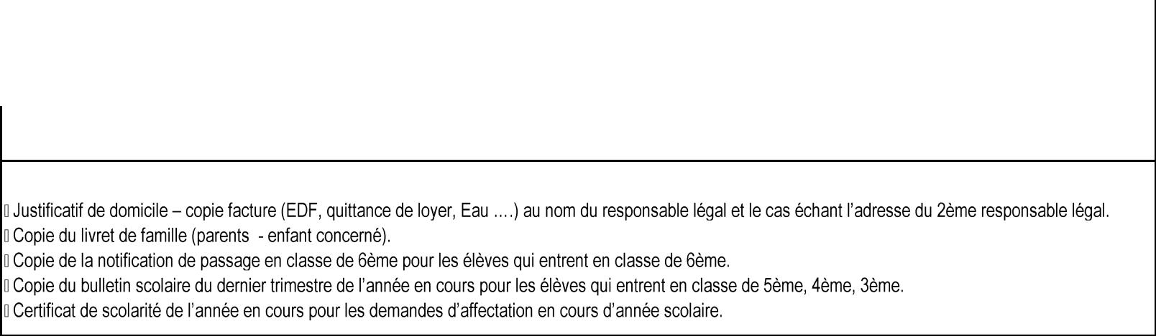

Pièces à joindre à votre demande :